Name:
Course/section:
Date
HW #
Chapter:

Instructions: Show all steps in your work to get full credit

- Find the resultant force for the forces shown by (a) using the parallelogram law and (b) by resolving the forces into their x and y components.
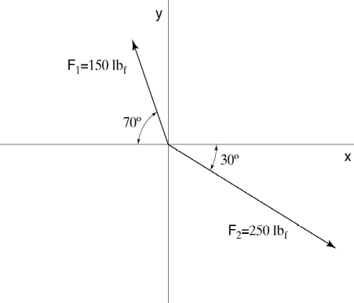

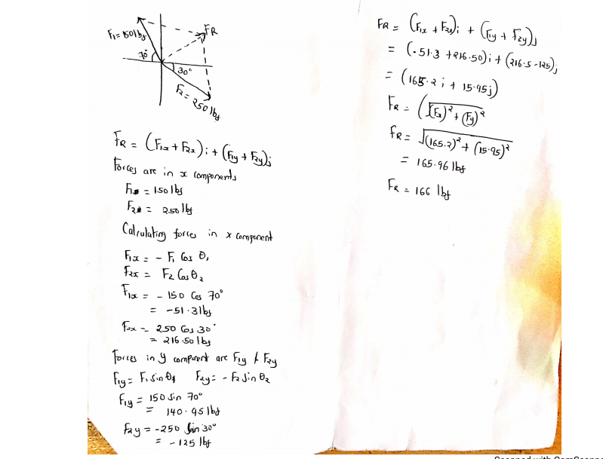
- Consider the three forces, F₁ = 5 i + 2 j kN, F₂ = −3 i − 8 j kN and F₃ = −4 i + 7 j kN. Find the resultant force, its magnitude, and direction with respect to the positive x-axis.
F_{R} = F1 + F2 + F3
F_{R} = (5 i + 2 j + (−3 i − 8 j) + (−4 i + 7 j)) kN
F_{R} = (5 i −3 i −4 i) +(2 j − 8 j + 7 j)
F_{R} = -2i + j
F_{Rx} = -2i
F_{Ry} = j
F_{Rx} = -2i kN

- A crate hangs by a rope as shown. Construct a free-body diagram of the crate.

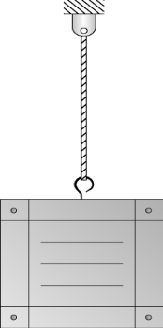

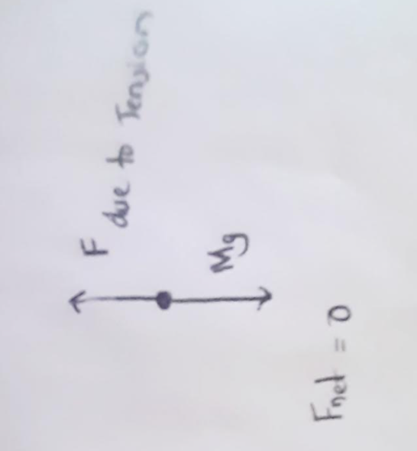

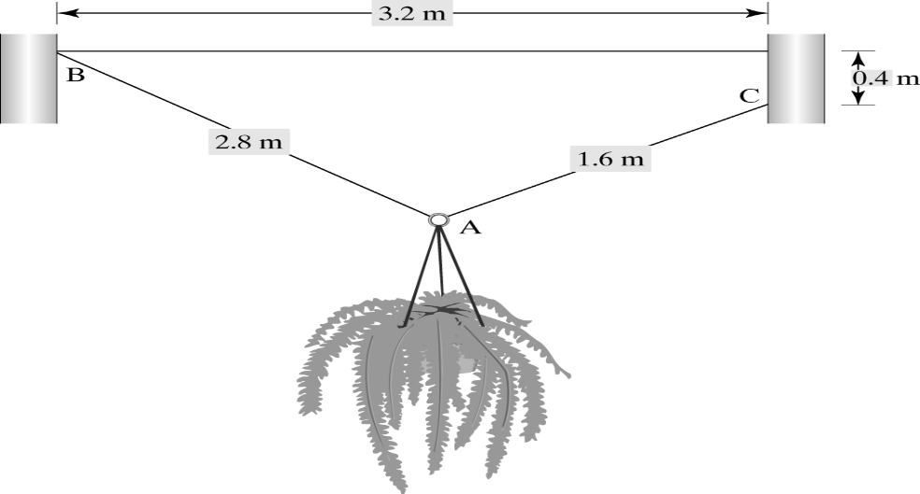

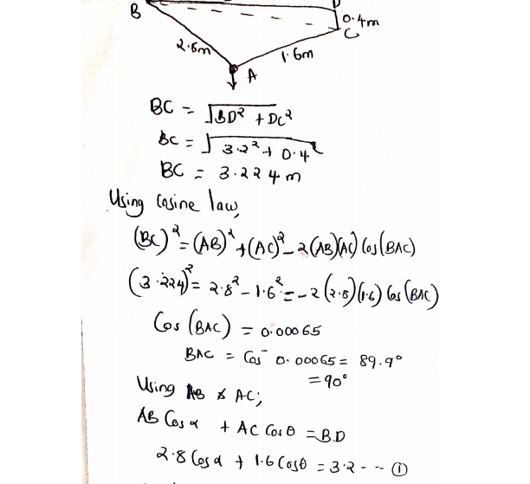

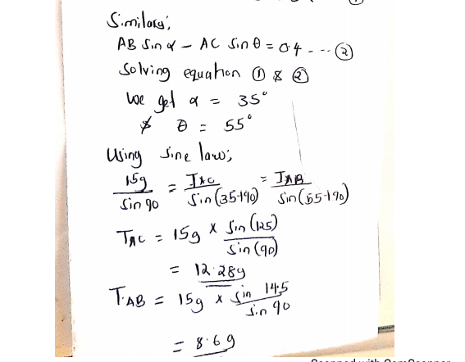

- A 8-m high granite column sustains an axial compressive load of 500 kN. If the column shortens 0.12 mm under the load, what is the diameter of the column? For granite, E = 70 GPa. Use the general analysis procedure to present your solution.

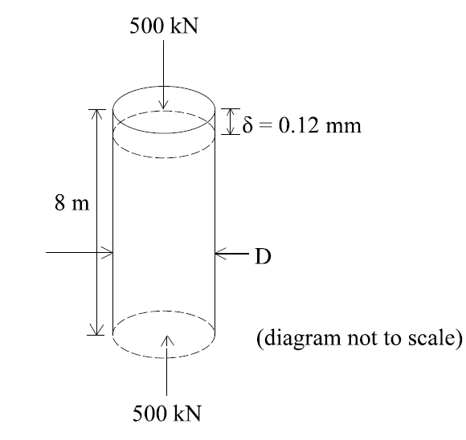

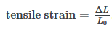
Tensile strain = $\frac{0.12*{10}^{-3}m}{8m}$ = 1.5 * 10⁻⁵
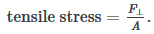
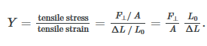
Y = Young’s modulus = E = 70 GPa.

7 * 10¹⁰ Pa = $\frac{F/A}{1.5*{10}^{-5}}$

Wher F = 500kN = 500,000N

7 * 10¹⁰ = $\frac{500,000}{A* 1.5*{10}^{-5}}$

A = $\frac{500,000}{1.5*{10}^{-5}*7*{10}^{10}}$ = 0.4762m²

A = $πr^{2}$
r = $\sqrt{\frac{0.4762}{π}}$ = 0.39
D = r*2 = 0.39 *2 = 0.78 m

